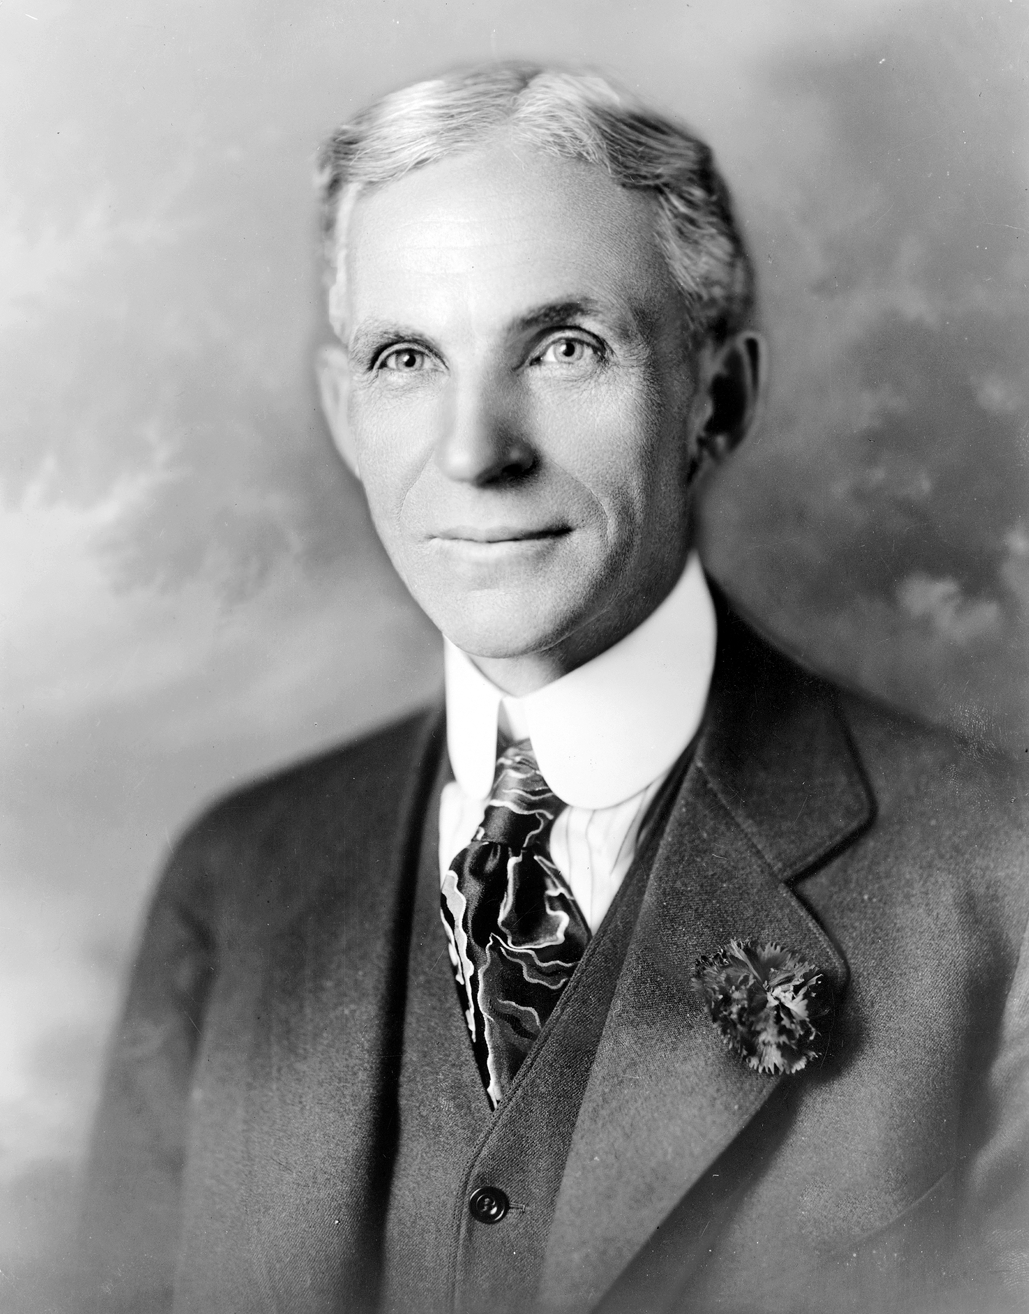

henry ford

*If you think you can do a thing or think you can't do a thing, you're right.*

*Quality means doing it right when no one is looking.*

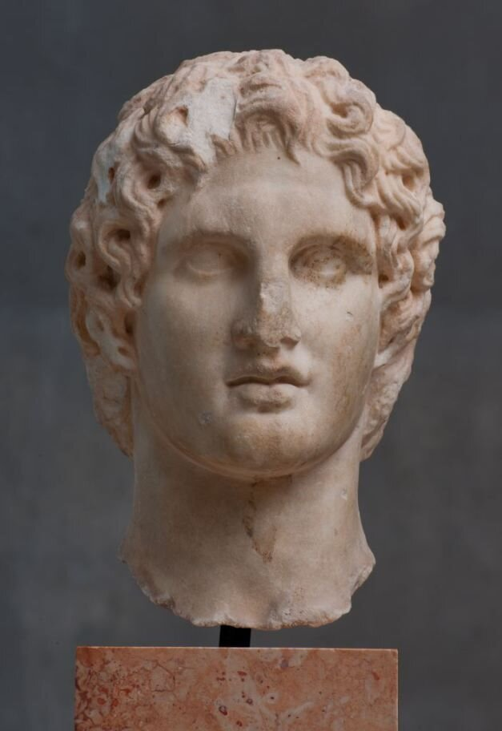

alexander the great

I am not afraid of an army of lions led by a sheep; I am afraid of an army of sheep led by a lion.  
 There is nothing impossible to him who will try.

When we give someone our time, we actually give a portion of our life that we will never take back.

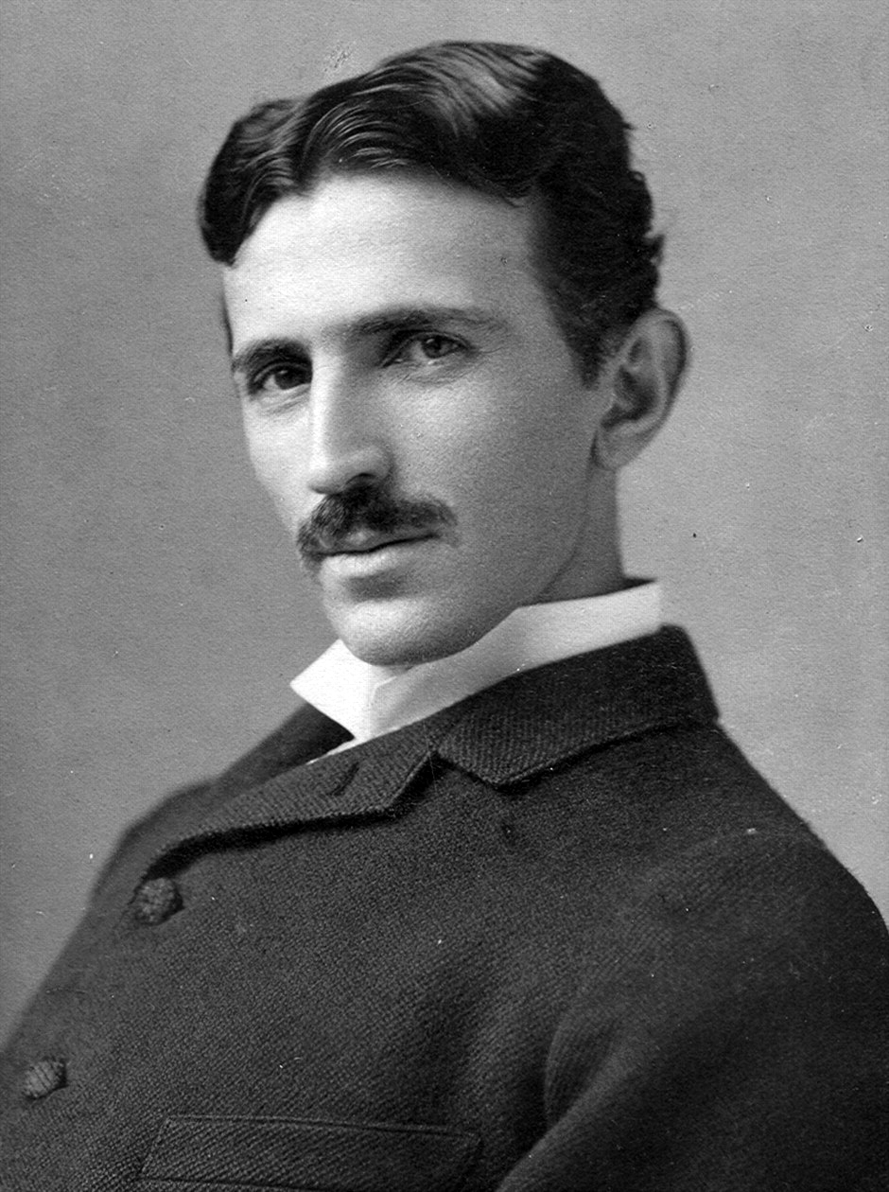

nikola tesla

I don’t care that they stole my idea … I care that they don’t have any of their own.

Of all things, I liked books best.

I do not think you can name many great inventions that have been made by married men.

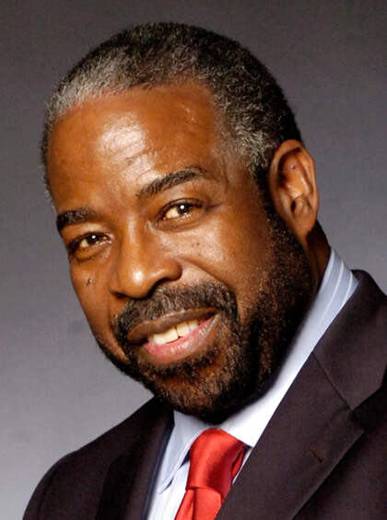

Les brown

You gotta be hungry.

Don't let someone else's opinion of you become your reality.

You are never too old to set another goal or to dream a new dream.

When life knocks you down, try to land on your back. Because if you can look up, you can get up. Let your reason get you back up.

Shoot for the moon and if you miss you will still be among the stars.

Help others achieve their dreams and you will achieve yours.

You don't get what you want in life. You get who you are!

Easy is not an option!

Do what is easy **and your life will be hard**. Do what is hard and your life will become easy.

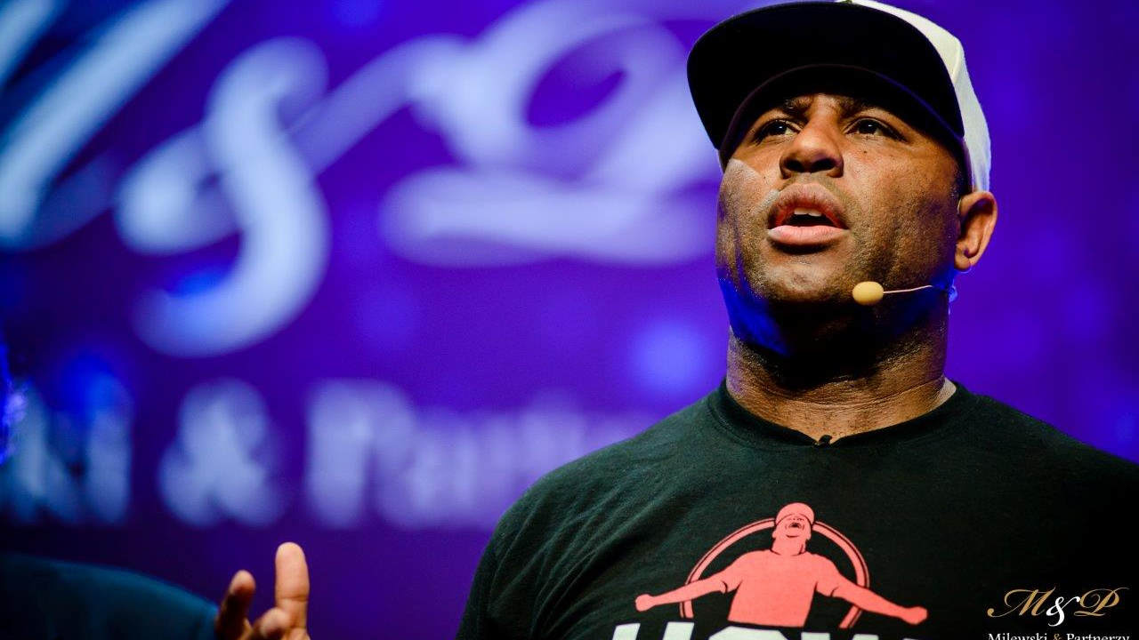Eric thomas

When you want to succeed as bad as you want to breathe, then you'll be successful.

Pain is temporary.

If you can look up, you can get up.

Everybody has a dream, but not everybody has a grind.

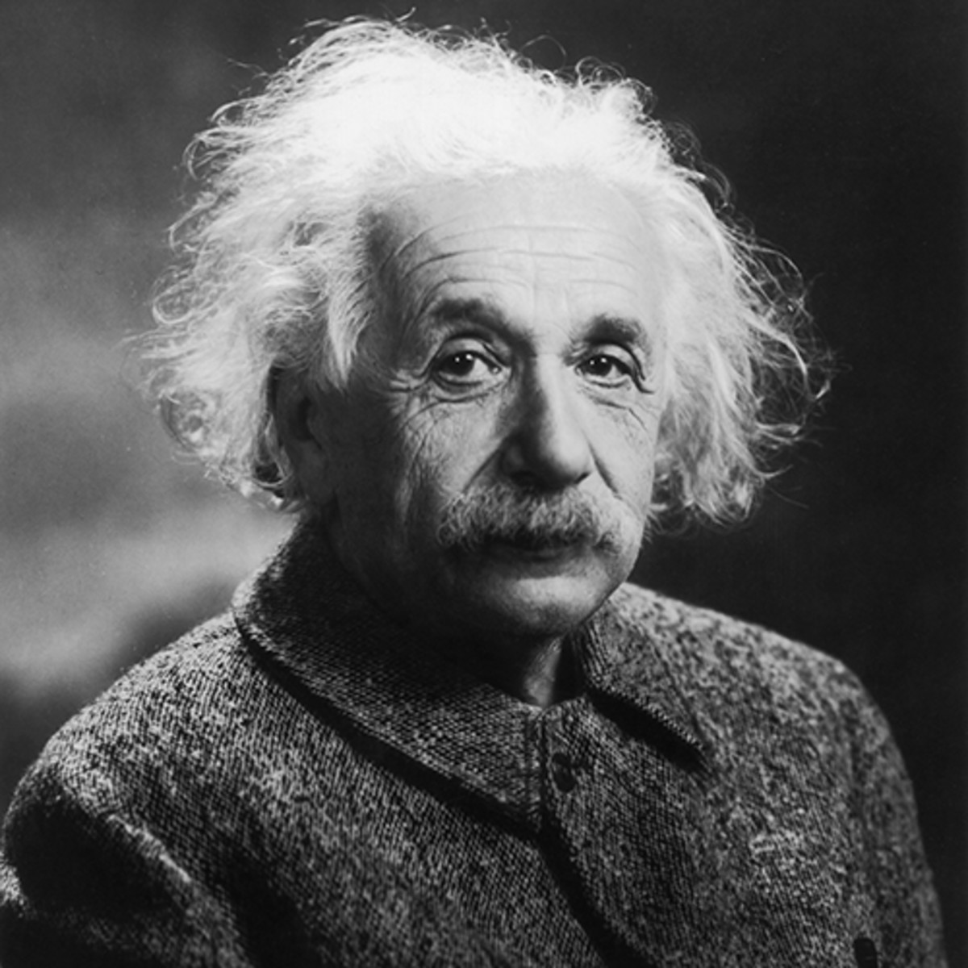

Albert Einstein

Imagination is more important than knowledge.

If you can't explain it simply, you don't understand it well enough.

Coincidence is God's way of remaining anonymous.

In the middle of difficulty lies opportunity.

The important thing is not to stop questioning. Curiosity has its own reason for existing.

Insanity: doing the same thing over and over again and expecting different results.

zig ziglar

You don't have to be great to start, but you have to start to be great.